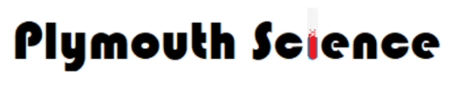
Year 6
Living things and habitats
Knowledge Organiser

rnnh
Science Capital (Scientists)
Classification
VOCABULARY
Organism- An organic living system composed of cells.
Microorganism- organism of microscopic size.
Fungus- part of Fungi kingdom includes yeast, rust, molds and mushrooms.
Bacteria- small single cell organisms found everywhere on earth.
Virus- microscopic parasites generally smaller than bacteria.
Fish- aquatic gill bearing animals
Amphibian- cold blooded vertebrate animal.
Insect- small arthropod animal which has 6 legs and generally one or two pairs of wings.
Reptile- a vertebrate animal typically with dry scaly skin and lay soft shelled eggs on land.
Bird- warm blooded egg laying vertebrate animal with feathers, wings and a beak.
Arachnid- an arthropod e.g. spiders and scorpions.
Mollusc- an invertebrate including snails, slugs, mussels and octopuses.
Vertebrate- animal with backbone
Invertebrate- animal without backbone.
Classification- To make smaller groups.

Aristotle was the first person to try and classify living things into groups.

Aristotle
384BC – 322BC

Carl Linnaeus was a Swedish scientist who believed it was a very important to have a standard system of classification.
Carl Linnaeus
1707- 1778

The Seven Level of Linnaeus’ System

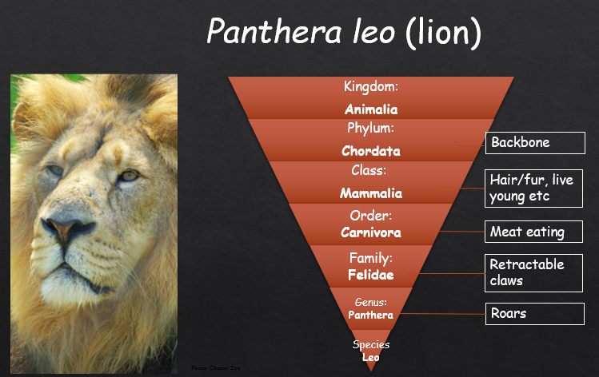
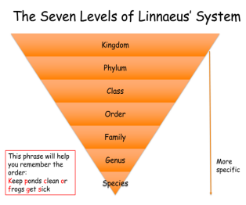








Year 6
Living Things and Habitats
Taxonomy
Reptiles
(Phylum Chordata, Class reptilia)
Birds
(Phylum Chordata, Class aves)
Mammals
(Phylum Chordata, Class mammalia)

Amphibians
(Phylum Chordata, Class Lissamphibia)

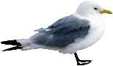

Microbes
Invertebrates
Cartilaginous Fish
(Phylum Chordata, Class Chondrichthyes)
Fish
(Phylum Chordata, Class Osteichthyes)



Famous Scientists:
Edward Jenner: discovery of smallpox
Alexander Fleming: penicillin.

