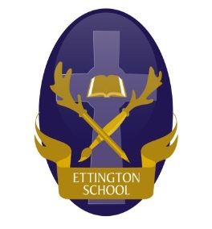
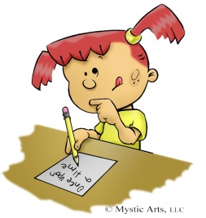
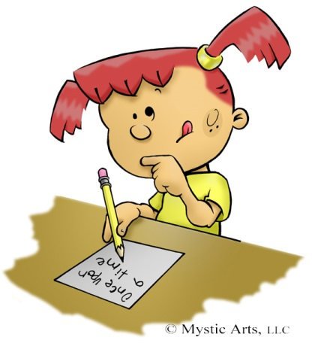
Ettington C of E Primary School
We invite you to attend an
EARLY WRITING
INSPIRE WORKSHOP
for ALL Reception ParentS
Great ideas about how you can support your child’s writing at home and what they should be able to do by the end of Reception. There will also be time to work alongside your child back in the classroom.
Monday 26th January 9.15am – 10.15am in the School Hall. Please sign in at the Main School Entrance.

…………………………………………………….
Reception Parent Inspire Workshop - Early Writing
Pupil’s Name: ………………………………………………… Parent’s Name(s): ………………………………………………………..
I/We shall/ shall not be able to attend the Parents’ Inspire Workshop on Monday 26th January 2026
Signature:
Please complete and return this form to school by Friday 23rd January 2026

